K8s lab part 1 section 1: Creating your CentOS VM

**Remember**: Text in red is supposed to be executed, text in blue needs to be pasted in or added. Text in green is output from the system.

Steps:

1. Download the CentOS 7.8 x64 minimal image from your favorite mirror: <http://isoredirect.centos.org/centos/7/isos/x86_64/>
2. Create a new virtual machine from VMware Workstation. Select “custom” and click next:

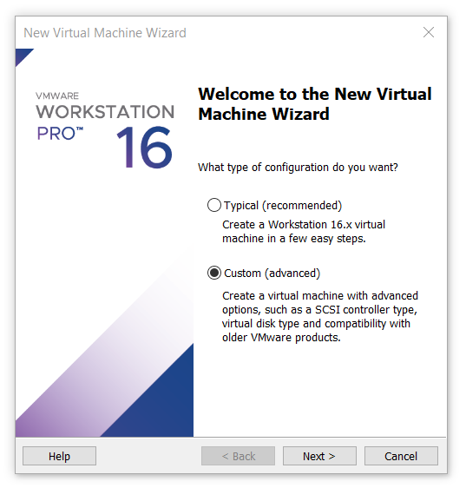

1. Select defaults for the Hardware Compatibility and click Next.
2. Select “Installer disc image file” and select you downloaded CentOS 7.8 Minimal ISO. Workstation should recognize the ISO as CentOS 7 64-bit. Finally click Next:

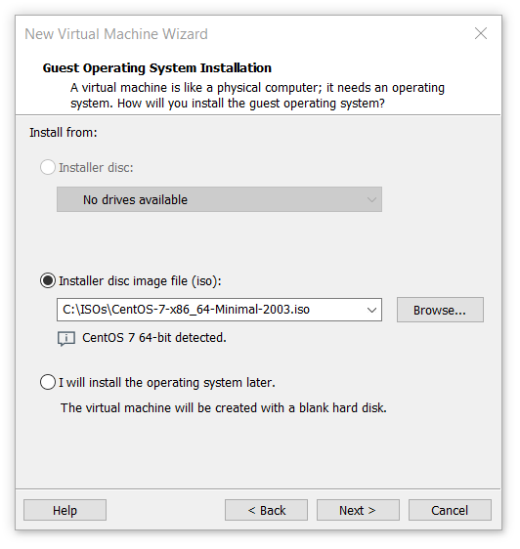

1. Name your VM and determine where to store it on your machine. Name it “k8s-controller”. Note: I usually create a new folder in C:\ just to make sure the VMs are not part of a OneDrive synced drive:

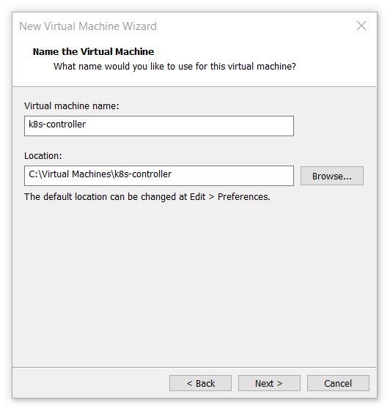

1. Select 1 processor, 2 cores per processor and click Next.
2. Select 1536MB of memory for this machine.
3. Select your favorite networking mode. Use either “bridged” (VM will sit on your local network and you need to know IP addressing etc) or select “NAT”:

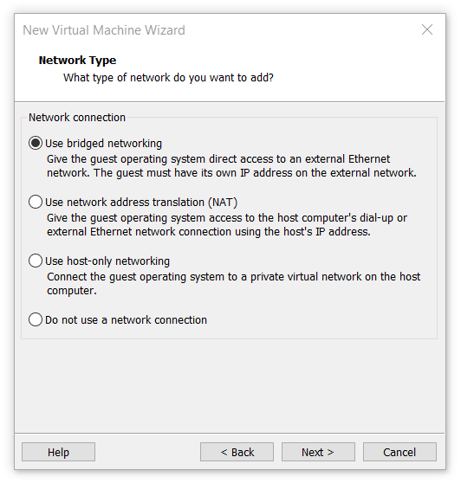

1. For storage, select all defaults and “next through” (LSI Logic, SCSI, Create new disk, 20GB).
2. Look at the overview of the VM to be deployed and start creation of your VM!

K8s lab part 1 section 2: Configuring your CentOS VM

1. As your VM boots look at its console to configure it further. Leave these at their defaults (English, English):

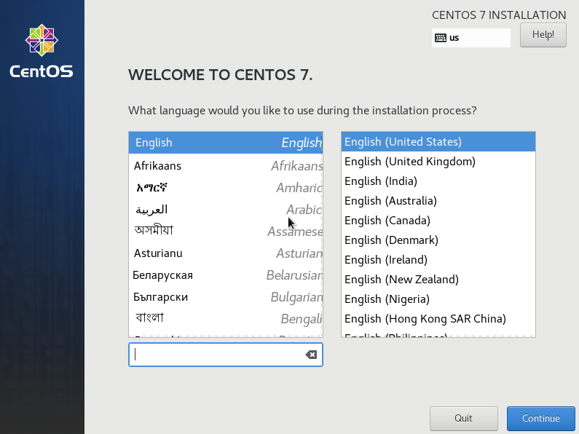

1. In the setup screen, start with network and hostname configuration. Start with enabling the ethernet port, filling in the hostname “k8s-controller” and selecting “configure…”:

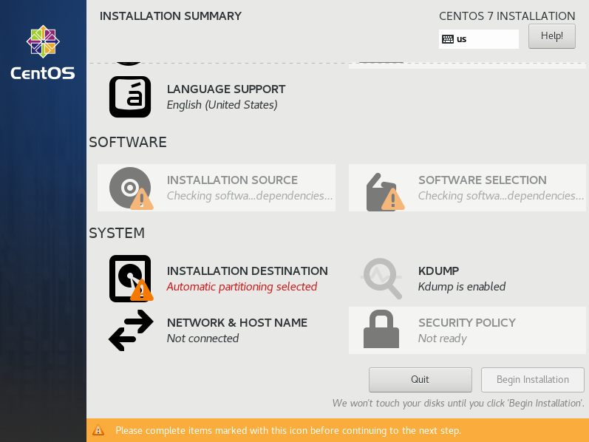 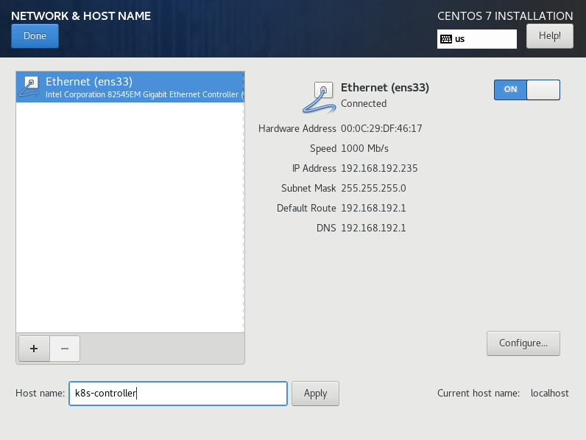

1. Go to the IPv4 Settings, select “Manual” method and add an IP address and DNS server. After that click “Save” and “Done”:

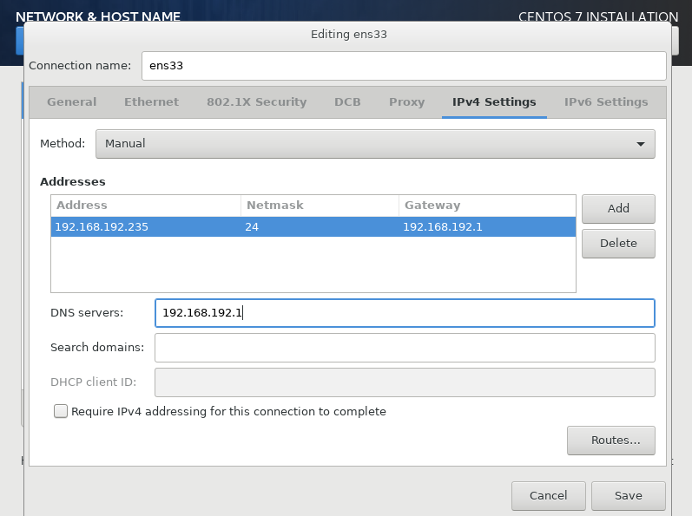

1. The Installation destination is filled out correct by default, but we need to verify this before we can install. So click it and confirm it by clicking “Done”:

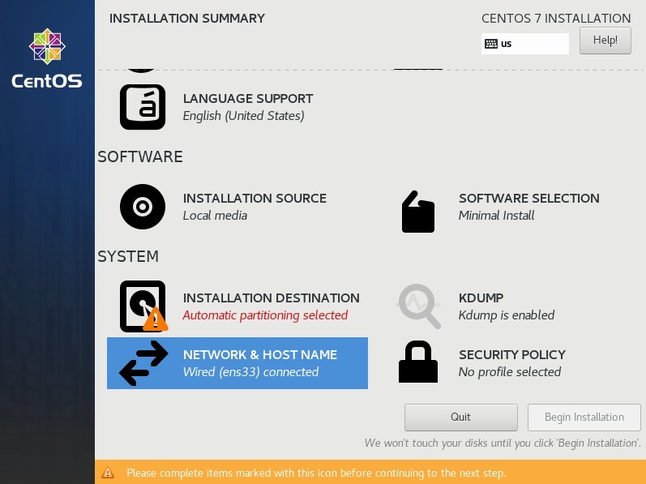

1. Finally, click on “date & time” and select your region and timezone. Save by clicking “Done”:

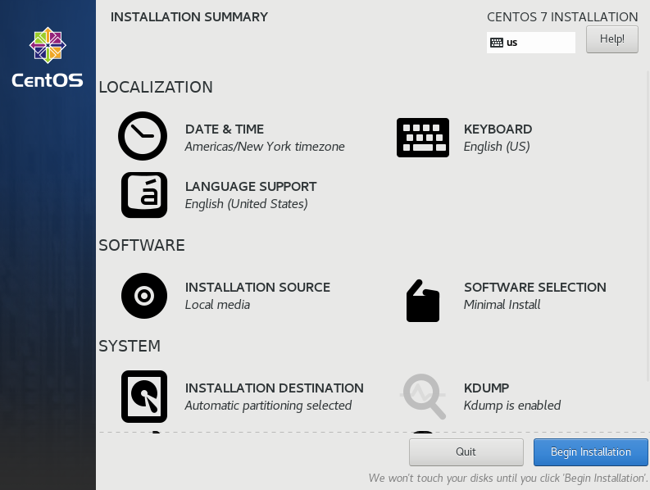 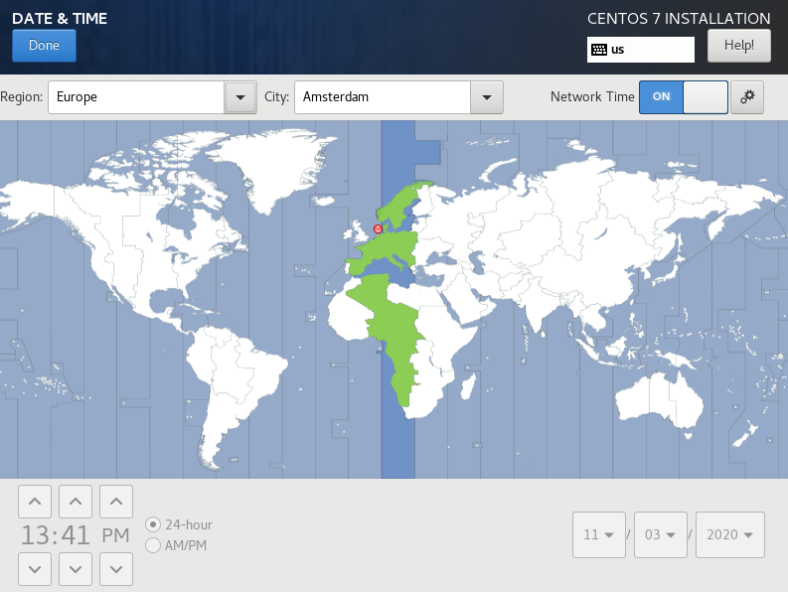

1. Now click “Begin Installation”. In the install screen, enter a root password (NOT a user password, we will use root access for this environment):

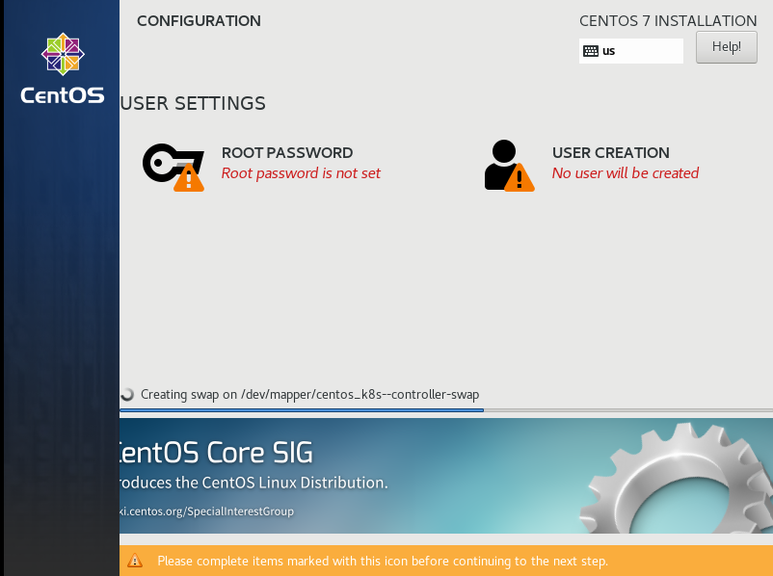 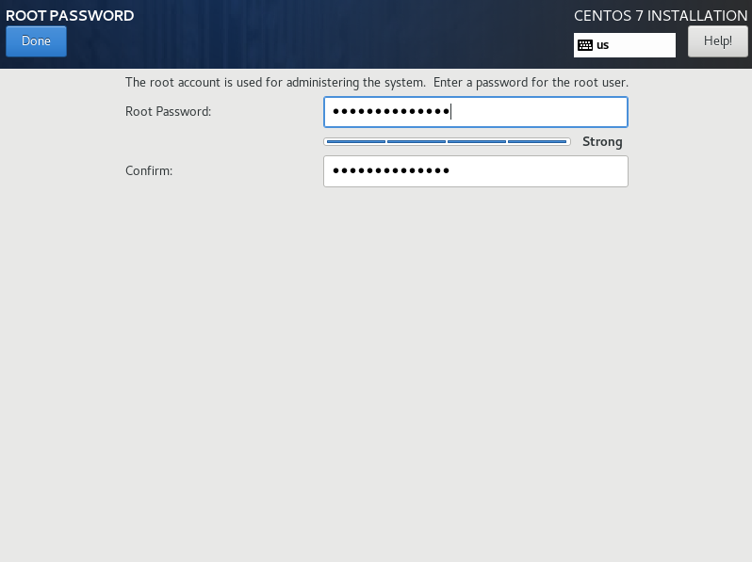

1. After the installation is finished, click “Reboot” to reboot the VM. At this stage you can also click the VMware Workstation Installation bar away (“I Finished Installing”):

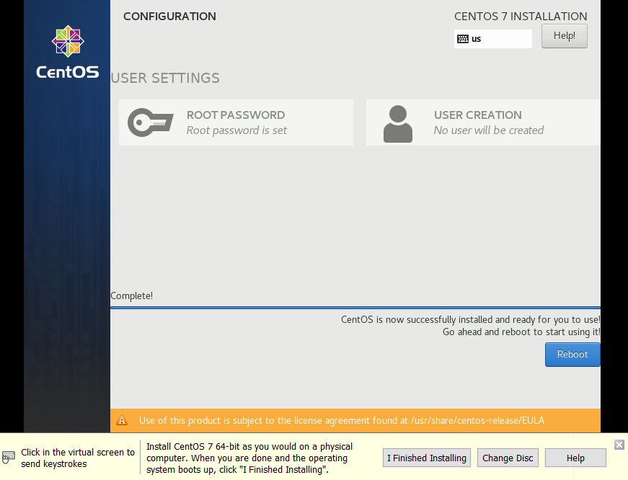

K8s lab part 1 section 3: Connecting to your CentOS VM

Finally we will connect to our newly created VM through SSH. SSH is enabled by default, so all we need to do it use an SSH client to connect. Putty works, but MobaXterm is recommended here. If you don’t have it, download and install it from here: <https://mobaxterm.mobatek.net/download-home-edition.html>

1. From MobaXterm, click “Session” and select “SSH” and type the IP address and username “root”. Then click “Bookmark settings” and change the “Session name” to “k8s controller”. After that click OK to save the session:

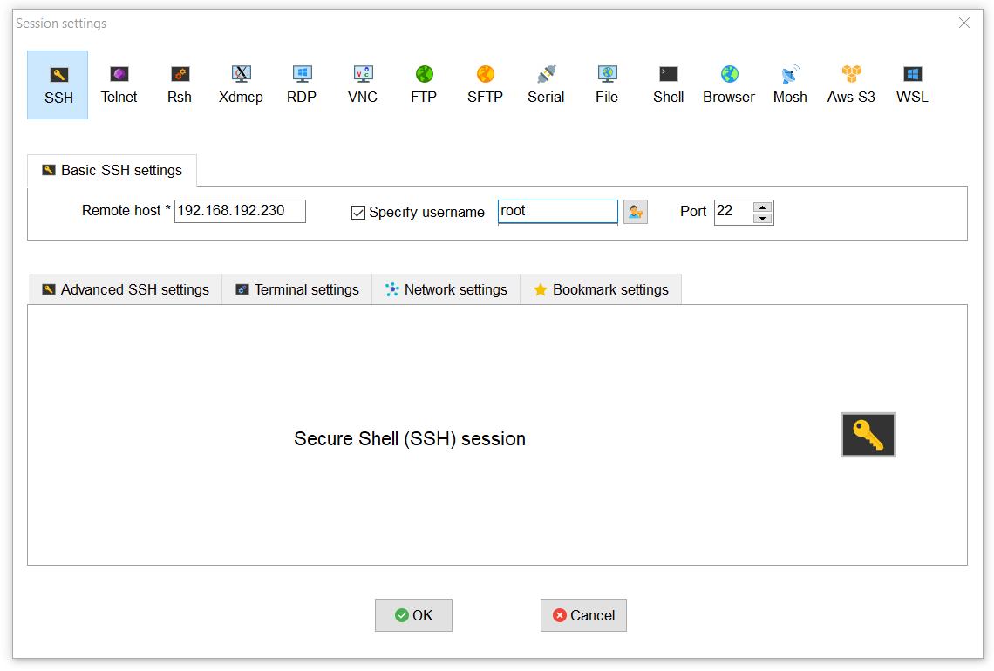 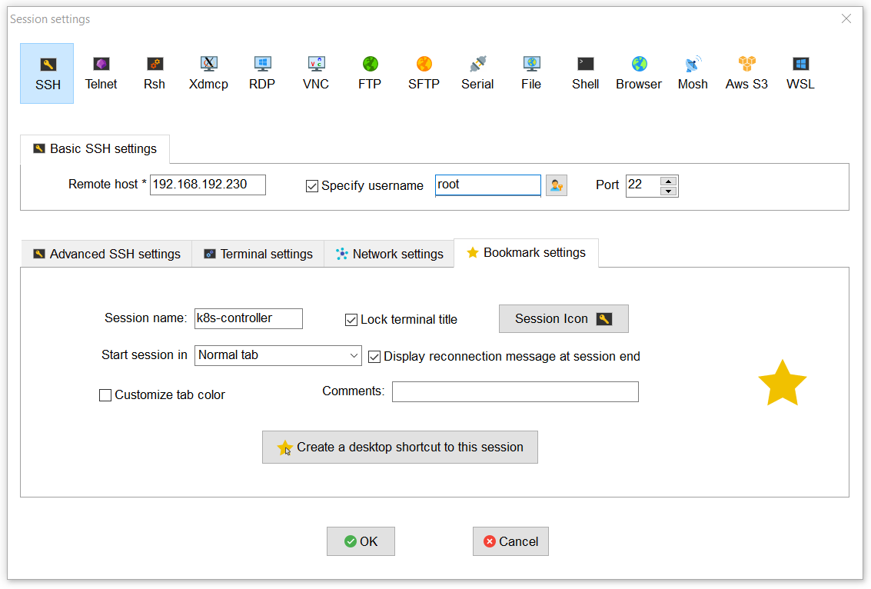

1. You should now see k8s-controller as a session on the left. Double click to connect to your VM. You may need to accept the certificate (so click “yes” if this pops up):

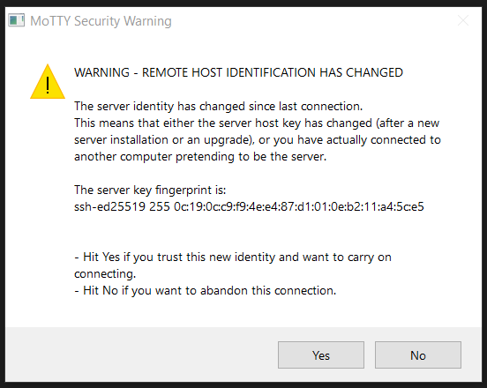

1. You should now be looking at your k8s-controller VM!

